11.1: Take the origin to be at the center of the small ball; then,
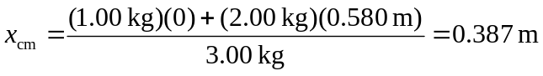
from the center of the small ball.

